

Brand and Social Media Analysis

Glossier

Courtney Lempner

Professor Walsh

**Brand Overview**

Glossier is a skin care, beauty, and makeup brand founded in 2014 by Emily Weiss in New York City. It first started as a blog, which is still operating today called, *Into The Gloss*, and then it developed into a brand. Glossier started as a “wild success” having over $100 million in sales within the first four years of their founding date according to *The* *New York Times* (Gupta, 2022). Glossier gained a lot of popularity and became trendy for having simple, fun, and colorful products. They primarily market their skin care and makeup products towards younger females between the ages of 16 and 25.

In the midst of the 2020 Covid-19 pandemic, Glossier was seeing a decline in the success of their company. Obviously, the pandemic caused a decline with most companies; however, post-pandemic, Glossier is still seeing a decline in their company. Recently, some complications with senior leadership have caused several employees to step down (Gupta, 2022) which has simultaneously caused a reduction in sales. The founder, Emily Weiss, has apologized and recently stepped down from her role (Gupta, 2022), but it will be interesting to see how Glossier moves forward in improving their reputation and sales.

**Purpose**

This paper will provide a brand and social media analysis on Glossier. By conducting the brand analysis, it will investigate the specifics of the brand, such as metrics and an analysis of their social media platforms as well as what sets them apart as a company. The purpose of this report is to identify areas for improvement for Glossier. The brand analysis will help indicate Glossier’s competitive offerings over other companies in the same industry.

Glossier is currently trying to recover their reputation from a few leadership issues that have been made public. Conducting this report will help to identify strengths (i.e. with their product offerings or with influencer partnerships) and then use it to their advantage when marketing on social media platforms. Having a good marketing strategy on socials has the ability to increase user attraction and produce more sales while also bettering their image.

**Competitors**

Glossier has a few competitors in the makeup industry. Two of their biggest competitors include Milk Makeup and Charlotte Tilbury. These competitors were selected based on the similarities in size, types of products they sell, in addition to similarities in the type of audiences.

**Milk Makeup Overview & Competitive Offerings**

Milk Makeup’s brand and products tend to be and look a little more sophisticated than Glossier, which attracts a more mature, older audience. This brand also indicates that they are “100% vegan, cruelty-free, and paraben-free” in all of their products (Milk Makeup, 2022). Milk Makeup’s audience is 32% male and 68% female within the ages of 18 to 24 years old. This company’s audience is very similar to Glossier’s audience age group; however, Milk tends to skew slightly older.

**Charlotte Tilbury Overview & Competitive Offerings**

Charlotte Tilbury, like Milk Makeup, is more of a sophisticated, upscale makeup brand. As listed on their website, Charlotte started as a “Makeup Artist to the Stars.” By this, the brand is advertising that celebrities and famous people are known to wear her makeup style. The audience of Charlotte Tilbury is the oldest out of Milk Makeup and Glossier, being between the ages of 24 and 35.

**Glossier’s Social Media Accounts**

[**Glossier’s Instagram**](https://www.instagram.com/glossier/?hl=en)

* **2.6 million** followers
* Instagram is Glossier’s most followed social media, so it is the most important and influential platform for them to be posting on
* Their instagram features posts with both celebrities and normal people using their products, mostly women
* In addition to people, animals also seem to be occasional subjects
* A lot of the messages that they post have are about sales going on, showcase the products in a creative positioning, or capture people wearing their makeup products
* Glossier’s tagline, “You Look Good” appears frequently in the picture part of the post
* Posts are not very serious, the sentiment they give off is light, fun, and comical

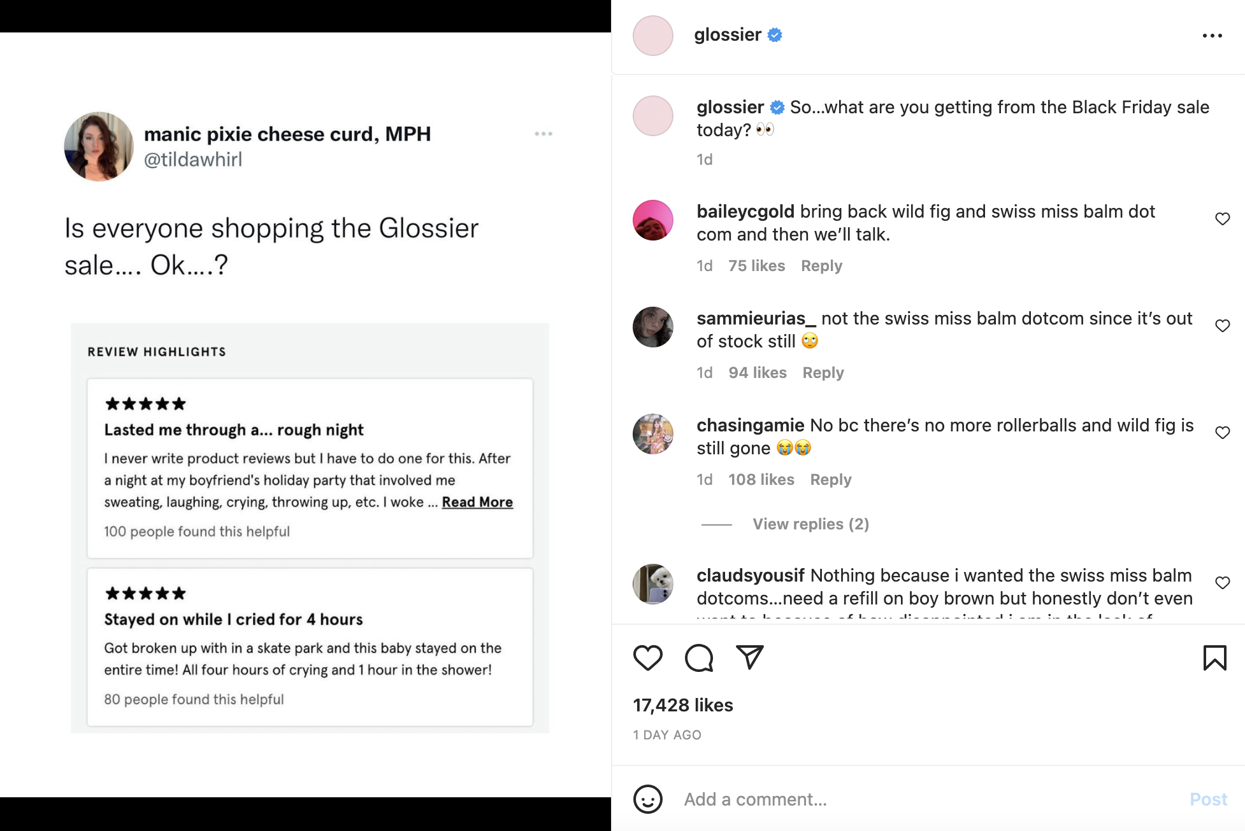

* Hashtags are not commonly used on their Instagram. There was only one, #GlossierIRL in the last few posts (Glossier In Real Life) which was used in posts when announcing new store locations
* Posts with the most likes and engagements were ones that indicated sales or partnerships with another brand (currently Swiss Miss hot chocolate) and influencers (Olivia Rodrigo)

[**Glossier’s Twitter**](https://twitter.com/glossier?lang=en)

* **106.3k** followers
* Twitter is the platform where Glossier has the lowest amount of followers
* Posting on this platform is not super frequent
* Brandwatch indicated that posts with Olivia Rodrigo (their current brand personality) had the highest level of engagement among their audience
* Twitter does not get many engagements at all on their posts
* An interesting finding on Twitter was that the company retweeted occasional posts of people tagging them

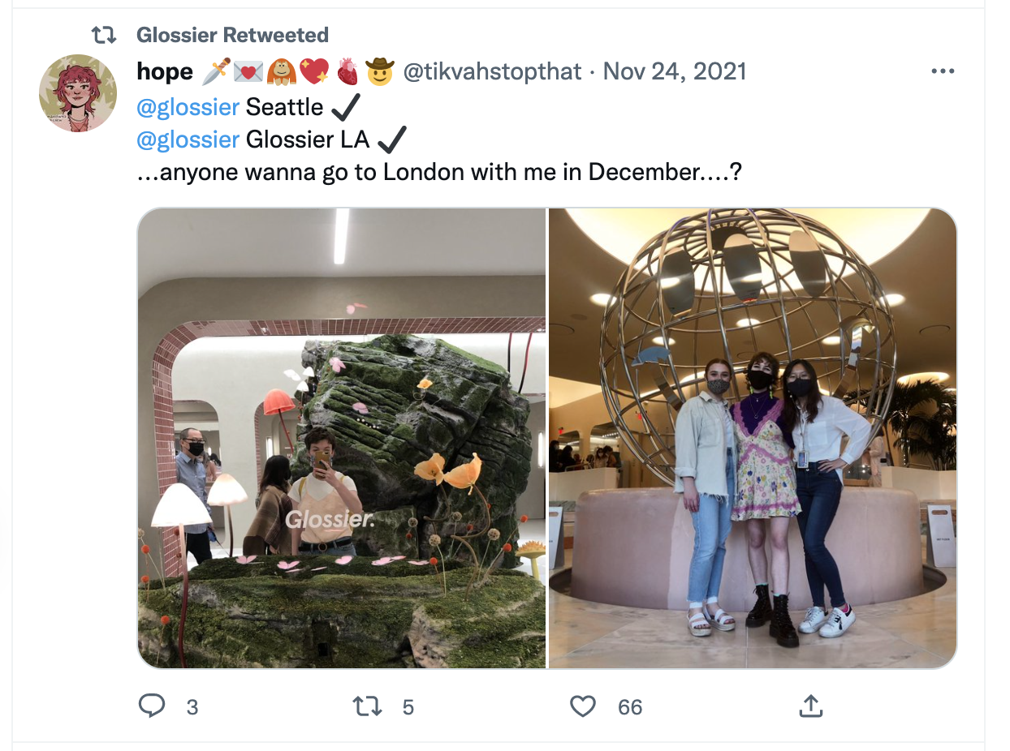

[**Glossier’s Facebook**](https://www.facebook.com/glossier/)

* **412.6k** followers
* Relatively active on this platform, posting several times a week
* Their posts overlap with their Instagram (duplicate posting)
* Since their posts are duplicates of their Instagram posts, there is a lot of information about discounts and colorful showcases of their products
* A prominent element to their Facebook page is that they have a ‘Shop’ section on the left hand side of posts

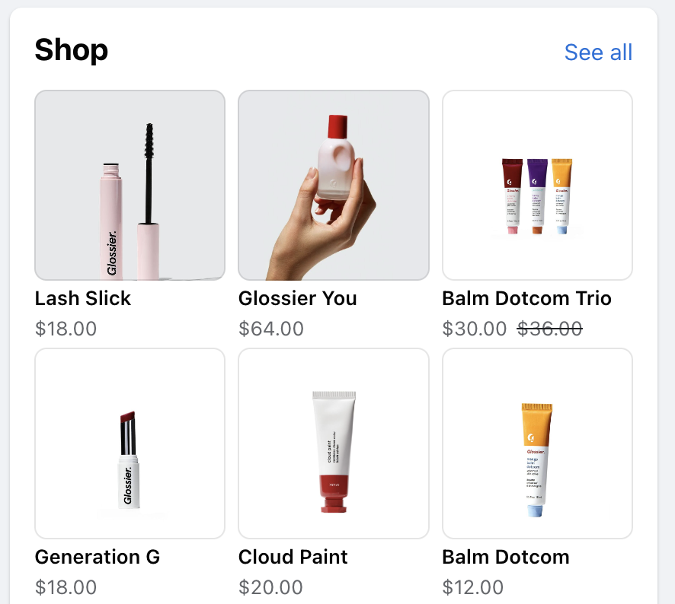

[**Glossier’s LinkedIn**](https://www.linkedin.com/company/glossier/)

* **215.6k** followers
* Very professional
* Most of the posts were articles that took the user to another page
* Other posts showed new hires or their employees receiving awards
* Not as colorful and fun as the posts on their Instagram, Twitter, or Facebook
* Not many hashtags on these posts
* Glossier tagged people or other companies in their posts

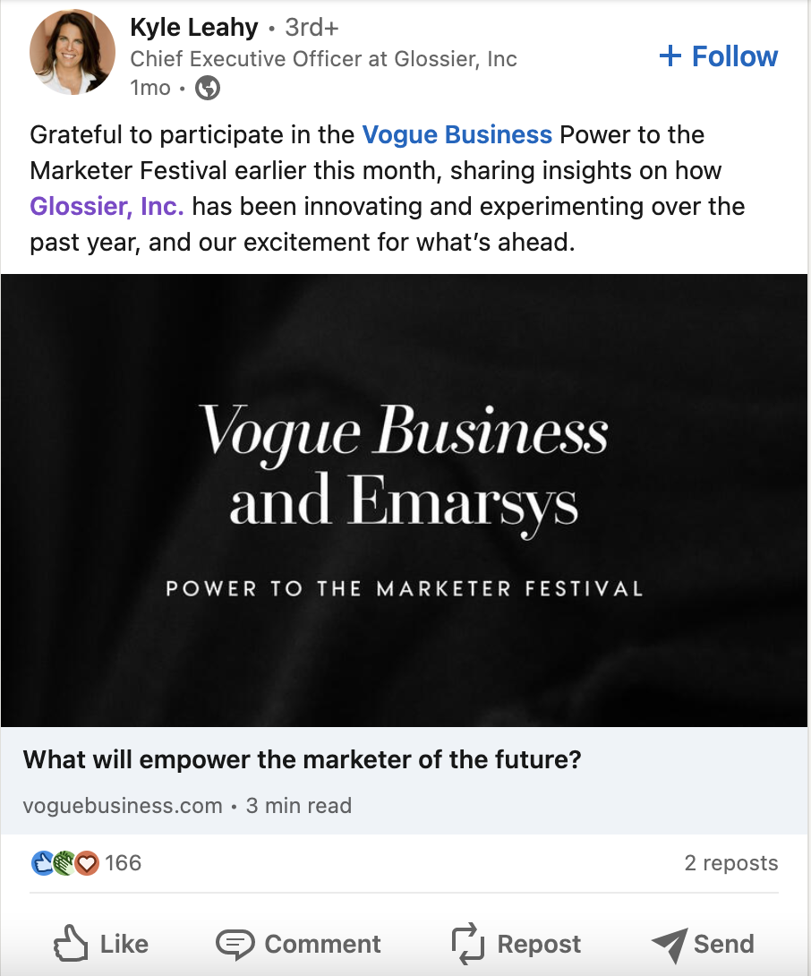

* Posts with the highest engagement were with Olivia Rodrigo or an announcement of their products being sold at Sephora in the future

[**Glossier’s YouTube**](https://www.youtube.com/channel/UCg17mivnAaXprAdgCgpWNBg)

* **155k** subscribers
* Posts every few months on YouTube, not super frequent
* The most common posts on their page are “Get Ready with Me” videos, where people are displaying how they get ready for their day using Glossier products



* They should post more with their current influencer, Olivia Rodrigo, as there are only three videos with her over the past several months
* They had between two and three hashtags in their posts, with topics that were relevant to what their video was showing. I.e. in a recent post showing their partnership with Swiss Miss hot chocolate, the hashtags included were #holiday, #glossier, #lipbalm

In addition to social media, Glossier has a blog called, *Into the Gloss*, which is linked on their main merchandise site. Having a blog that posts aboutGlossier’s products, new trends and styles, and other articles about the fashion world, is a powerful marketing strategy. In the “About Glossier” section of their website, they specify that *Into the Gloss* is a “beauty website devoted to people sharing the products they love, and our source for inspiration and information.” It creates excitement among their audience about the brand and the products they offer.

**Suggestions for the Future**

Overall, Glossier does a good job of keeping what they’re posting consistent on all of their social media platforms. Their posts make their products look attractive to the audience and they do a good job of marketing their products by posting normal people using them. People like to see influencers using and supporting a company's products, but also seeing normal people posted on their social media shows that the products are for anyone.

There are a few things that the company can work on for the future. Glossier should make more efforts to create partnerships with influencers. Their most recent partnership with a popular singer-songwriter, Olivia Rodrigo, gained a lot of attention and engagement on their social media platforms. Having more prominent influencers represent their company can help them to improve interactions and engagements on their social media platforms. Additionally, if the audience sees an influencer they like supporting a brand, they may be more inclined to buy the brand’s products. Another suggestion for the company would be to create more promotion for their blog website, *Into the Gloss*. An interesting aspect to the company is that they have this blog site, so they should leverage it more as a marketing tool with their audience. The blog site is listed as an external link on their main website; however, it does not stand out where it is listed. It would also be beneficial for Glossier if they were more active on all of their social media platforms. Glossier is posting the most on their Instagram account, which makes sense due to it being their account with the highest number of followers. However, if Glossier was more active in posting on other platforms, on a weekly basis, that could help them gain more followers on other social media. In this research, I found it surprising that Glossier was posting frequently on Facebook. With their audience age in consideration, it would be in their best interest to be posting on a platform with a typically younger audience. Facebook does attract an older audience, so it would be beneficial to be posting more on a platform like Twitter, where more people in their target audience are present. Glossier can also work on being more interactive with the audience. For example, on their Twitter they were reposting some people’s Tweets. They can interact with people on other platforms by responding to comments, which will show their attentiveness and customer service.

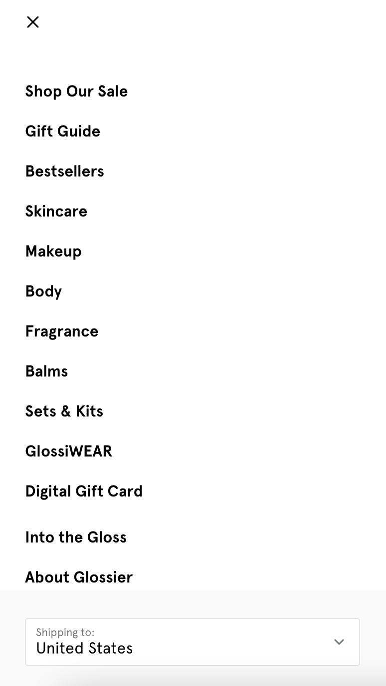



**Sources:**

<https://www.retaildive.com/news/two-dozen-layoffs-glossier/628767/>

<https://www.nytimes.com/2022/05/26/style/glossier-emily-weiss.html>

<https://www.linkedin.com/pulse/target-customers-glossier-elaine-cho/>

<https://www.similarweb.com/website/glossier.com/competitors/>

<https://www.glossier.com/pages/about>

<https://intothegloss.com/>

<https://www.charlottetilbury.com/us/content/charlottes-story>

<https://www.similarweb.com/website/milkmakeup.com/#:~:text=milkmakeup.com%20Audience%20Demographics&text=milkmakeup.com's%20audience%20is%2031.48,24%20year%20olds%20(Desktop)>.

<https://www.instagram.com/p/CkQ0mPNMGxA/?hl=en>

<https://www.linkedin.com/company/glossier/posts/?feedView=all>

[https://www.facebook.com/glossier/​​](https://www.facebook.com/glossier/%E2%80%8B%E2%80%8B)

<https://milkmakeup.com/collections/cyber-monday-makeup-deals-2022?g_acctid=810-417-8473&g_campaign=Finch%20-%20Milkmakeup.com%20-%20Brand%20Search&g_campaignid=1056206340&g_adgroupid=52579912300&g_adid=636575720122&g_keyword=milk%20make%20up&g_keywordid=kwd-4428092499&g_network=g&gclid=Cj0KCQiA-JacBhC0ARIsAIxybyPMauuXIe9kfhtlW4KzxQ0vndmYQdDpMVmjmKkJ9q87DezQv55RWAsaAit5EALw_wcB>

<https://twitter.com/glossier?lang=en>

<https://www.youtube.com/channel/UCg17mivnAaXprAdgCgpWNBg>

<https://unmetric.com/brands/glossier>

[https://www.similarweb.com/website/glossier.com/competitors](https://www.similarweb.com/website/glossier.com/competitors/)